Tasmania Police
Recruiting Services
Tasmania Police Swimming Instructions
Instructions for the applicant:
- To book an appointment with an AUSTSWIM accredited centre, visit www.austswim.com.au and click on the ‘Find a swim centre’ link near the centre of the page. To find a centre nearest you enter your suburb or postcode and tick the ‘AUSTSWIM Assessor Available’ box.
- When you attend your assessment you’ll need to provide the assessor with:
  - your driver’s licence or other form of photo identification
  - a printed copy of these instructions
  - the Certificate of Swimming Proficiency provided on page 3.
- You’ll need a pair of long pants (light weight pants/trousers or similar) and a short sleeve shirt to swim in for the whole test.
- There’s an assessment fee payable to the pool you’re completing your test at. This covers your pool entry, assessment and certification. This fee is for one attempt only. If further assessments are required you’ll need to pay additional fees.
- Once you’ve successful completed your assessment, email the completed certificate to Tasmania Police Recruitment Services at recruiting@police.tas.gov.au along with your Professional Suitability Application and other required documents.

Instructions for the licenced AUSTSWIM assessor:
- View the applicant’s driver’s licence or other form of photo identification and record details on the Certificate of Swimming Proficiency form.
- Collect the assessment fee.
- Check that the applicant has the correct clothing for the test.
- Complete the Tasmania Police Swimming Proficiency Test as detailed on page 2.
- If the applicant successfully completes the assessment, complete the certificate and return it to the applicant.

Tasmania Police Recruiting Services
Tasmania Police Academy, 151 South Arm Highway, Rokeby Tasmania 7109
Phone: 1800 628 680 (toll free from landlines within Australia) | Email: recruiting@police.tas.gov.au

Tasmania Police Swimming Proficiency Test
Assessment instructions:
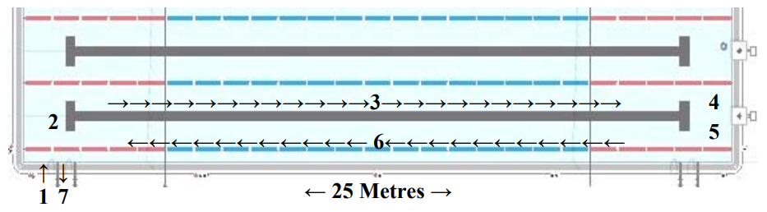
Swim proficiency test diagram:

- Enter the water safely and appropriately (slide in entry for shallow water less than 1.5 metres or shallow dive for water deeper than 1.5 metres).
- Float, scull or tread water for one minute with feet off the bottom of the pool.
- Swim 25 metres with head above water to a target area using freestyle or survival breaststroke.
- Float, scull or tread water for one minute with feet off the bottom of the pool.
- Duck dive to the bottom of the pool and retrieve a weighted object (2kg rubber brick or similar) from the bottom of the pool.
- Return tow-weighted object swimming 25 metres using either sidestroke or lifesaving backstroke.
- Exit the water appropriately.

Notes:
- The test must be completed in a 25 metre swimming pool.
- The starting point must be at the shallowest end of the pool.
- The deepest end of the pool must be no less than 1.2 metres and no more than 2.0 metres.
- The applicant must wear long pants (light weight pants/trousers or similar) and a short shelve top throughout the test.
- The applicant must complete the test continuously without stopping, putting their feet down or touching the sides of the pool.
- The weighted object may be a rubber brick or a similar object weighing around 2kgs.

Certificate of Swimming Proficiency

To be completed by the applicant:
Given name:
Surname:
Residential address:
Suburb:
State: |  | Postcode:
Applicant’s signature: |  | Date:

To be completed by the licenced AUSTSWIM assessor:
Has a driver’s licence or other form of photo identification been sighted? Please tick Yes No
The above applicant (full name):
Has successfully demonstrated the ability to complete the following swimming proficiency test:
- Enter the water safely and appropriately (slide in entry for shallow water less than 1.5 metres or shallow dive for water deeper than 1.5 metres).
- Float, scull or tread water for one minute with feet off the bottom of the pool.
- Swim 25 metres with head above water to a target area using freestyle or survival breaststroke.
- Float, scull or tread water for one minute with feet off the bottom of the pool.
- Duck dive to the bottom of the pool and retrieve a weighted object (2kg rubber brick or similar) from the bottom of the pool.
- Return tow-weighted object swimming 25 metres using either sidestroke or lifesaving backstroke.
- Exit the water appropriately.
AUSTSWIM Assessor’s signature:
Name of AUSTSWIM Assessor:
AUSTSWIM licence number: |  |  | Expiry date:
Address of pool:
Phone number of pool:
Date of assessment:

